# PROCESS MODELING

Process modeling, sometimes called structured analysis and design, is an analysis and design technique that describes processes that transform inputs into outputs. Tools that a systems analyst uses for process modeling include entity-relationship diagrams, data flow diagrams, and the project dictionary.

## ENTITY-RELATIONSHIP DIAGRAM (ERD)

An entity-relationship diagram (ERD) is a tool that graphically shows the connections among entities in a system. An entity is an object in the system that has data. For example, a cybercafé might have customer, order, menu item, computer, and vendor entities.

On the ERD, entity names usually are nouns written in all capital letters. Each relationship describes a connection between two entities. In the ERD shown in Figure 1, a vendor supplies one or more computers to the cafés. A computer is supplied by a single vendor. A customer may or may not use one of these computers during a visit to the café. A customer may or may not place an order. Some customers place multiple orders. Each order contains one or more items from the menu.

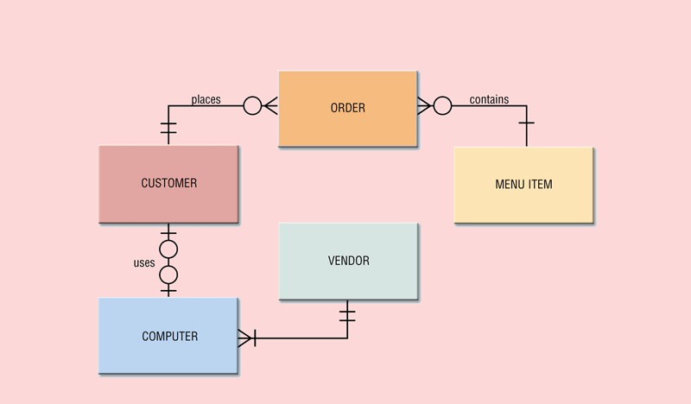

Figure : Example of an entity-relationship diagram (ERD).

## DATA FLOW DIAGRAMS

A data flow diagram (DFD), shown in Figure 2, is a tool that graphically shows the flow of data in a system. The key elements of a DFD are the data flows, the processes, the data stores, and the sources. A data flow, indicated by a line with an arrow, shows the input or output of data or information into or out from a process. A process, which is drawn as a circle, transforms an input data flow into an output data flow. A data store, shown as a rectangle with no sides, is a holding place for data and information. Examples of data stores are filing cabinets, checkbook registers, or electronic files stored on a computer. A source, drawn as a square, identifies an entity outside the scope of the system. Sources send data into the system or receive information from the system.

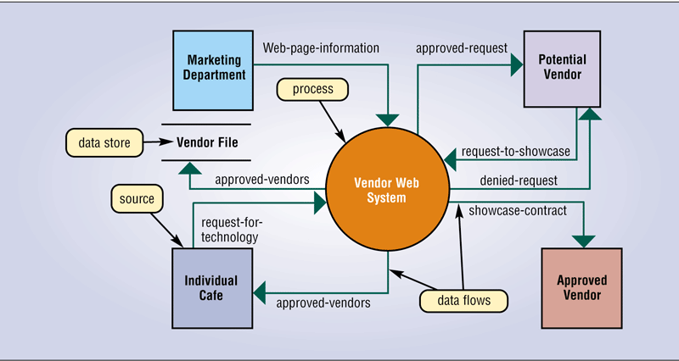

Figure : A data flow diagram (DFD).

## PROJECT DICTIONARY

The project dictionary, sometimes called the repository, contains all the documentation and deliverables of a project. The project dictionary helps everyone keep track of the huge amount of details in a system. The dictionary explains every item found on DFDs and ERDs. Each process, data store, data flow, and source on every DFD has an entry in the project dictionary. The dictionary also contains an entry for each data item associated with the entities.

The number of entries added to the dictionary at this point can be enormous. As you might imagine, this activity requires a huge amount of time. The systems analyst uses a variety of techniques to enter these items in the project dictionary. Some of these include structured English, decision tables, and decision trees. Structured English is a style of writing that describes the steps in a process. A decision table is a table that lists a variety of conditions and the actions that correspond to each condition. A decision tree also shows conditions and actions, but it shows them graphically.

# OBJECT MODELING

Sometimes called object-oriented (OO) analysis and design, object modeling combines the data with the processes that act on that data into a single unit, called an object. An object is an item that can contain both data and the procedures that read or manipulate that data. Each data element is called an attribute or property. The procedure in the object, called an operation or method, contains activities that read or manipulate the data.

Object modeling can use the same tools as those used in process modeling. Many systems analysts, however, choose to use tools defined in the UML. Although used in all types of business modeling, the UML (Unified Modeling Language) has been adopted as a standard notation for object modeling and development. The UML is a graphical tool that enables analysts to document a system. It consists of many interrelated diagrams. Each diagram conveys a view of the system.

Instead of developing their own object diagrams and steps in an object-oriented system development cycle, most companies use an existing methodology to guide them through the steps in the system development cycle. A popular methodology on the market today that uses the UML is the Rational Unified Process (RUP) by Grady Booch, Ivar Jacobsen, and James Rumbaugh.

The latest UML version includes 13 different diagrams to assist the analyst in modeling the system. Two of the more common tools are the use case diagram and class diagram. The next sections describe these two diagrams.

## USE CASE

A use case diagram graphically shows how actors interact with the information system. An actor is a user or other entity such as a program. The function that the actor can perform is called the use case. Thus, a use case diagram shows actors and their use cases. As shown in Figure 3, the actor is drawn as a stick figure that connects to each use case with an arrow.

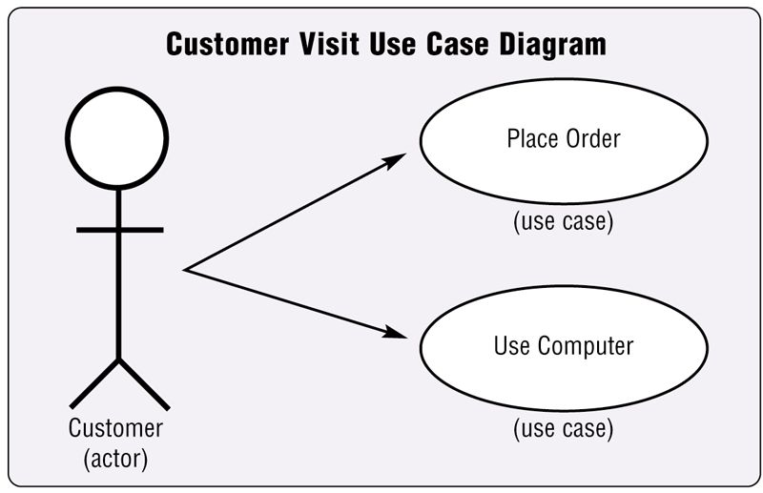

Figure : A use case diagram.

Because these diagrams are easy to understand, analysts find that the use case diagram is an ideal tool for communicating system requirements with users.

## CLASS DIAGRAM

A class diagram graphically shows classes and subclasses in a system. On a class diagram, objects are grouped into classes. Each class can have one or more lower levels called subclasses. Each subclass inherits the methods and attributes of the objects in its higher-level class. Every object in a class shares methods and attributes that are part of its higher-level class. This concept of lower levels inheriting methods and attributes of higher levels is called inheritance. A simplified class diagram with two subclasses is shown in Figure 4. In the figure, Food Order and Drink Order are subclasses of the higher-level class, called Order. All orders have an Order Number and Order Date (which would be attributes in the Order object), but only drink orders have a Size attribute (with values of small, medium, or large).

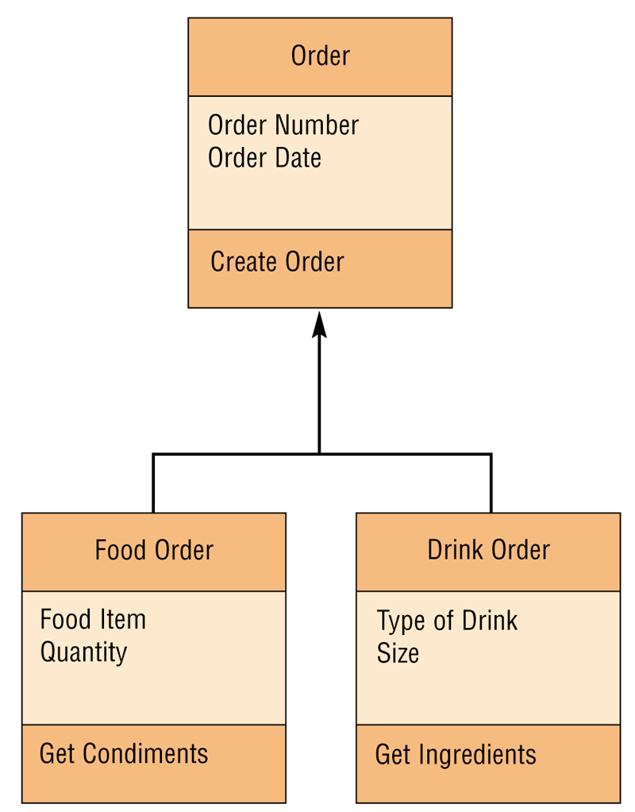

Figure : Simplified class diagram with two subclasses: Food Order and Drink Order.